3.6.2.2 CSS Validation Method
The deployed Moonlight WMS website was entered into the W3C CSS Validator. The validator automatically scanned the production CSS file generated during the React/Vite build process.
The CSS file tested was the compiled and minimized production stylesheet found in the /assets/ directory of the website. As project uses React, Vite, and Tailwind CSS, the final CSS also contains system-generated styles, responsive utility classes, browser-specific vendor prefixes, and CSS variables.
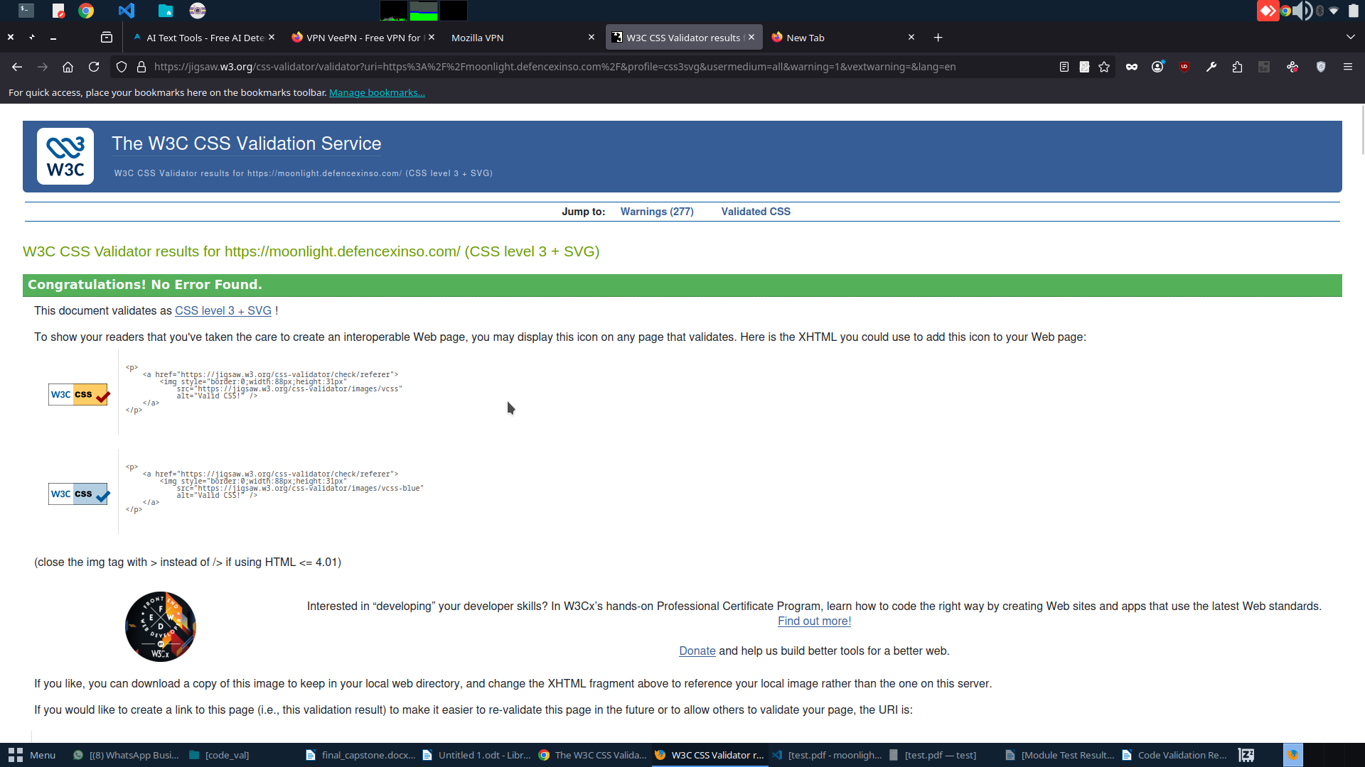Figure 12: W3C CSS Validator result showing that Moonlight WMS CSS passed with no errors.

3.6.2.3 CSS Validation Result
The W3C CSS Validator reported that the Moonlight WMS stylesheet contained no CSS errors. This means the stylesheet successfully passed CSS validation and was recognised as valid under the selected standard.
Validation Item | Result
Validation Standard | CSS Level 3 + SVG
CSS Errors Found | 0
Warnings Found | 277
Overall Status | Passed
The most important result is that no CSS errors were found. This confirms that the project’s CSS does not contain invalid syntax or critical CSS rule errors that would prevent the browser from understanding the stylesheet.

3.6.2.4 Warning Summary
Although no errors were found, the validator reported 277 warnings. These warnings were not critical errors. Most of them were related to browser-specific CSS properties and generated framework styles.
Warning Type | Example | Explanation
Vendor extensions | -webkit-appearance, -moz-tab-size, -o-object-fit | These are browser-specific CSS properties used to support Chrome, Safari, Firefox, and other browsers.
Vendor pseudo-elements | ::-webkit-scrollbar, ::-moz-placeholder | These are used to style browser-specific interface elements such as scrollbars and placeholders.
Vendor pseudo-classes | :-webkit-autofill, :-moz-focusring | These are used for browser-specific form styling and focus behaviour.
CSS variables warning | “CSS variables are currently not statically checked” | The validator cannot fully analyse dynamic CSS variables because their final value may depend on runtime conditions.
Font family warnings | Font family names containing whitespace should be quoted | Some generated font-family declarations require quotation for strict validation.

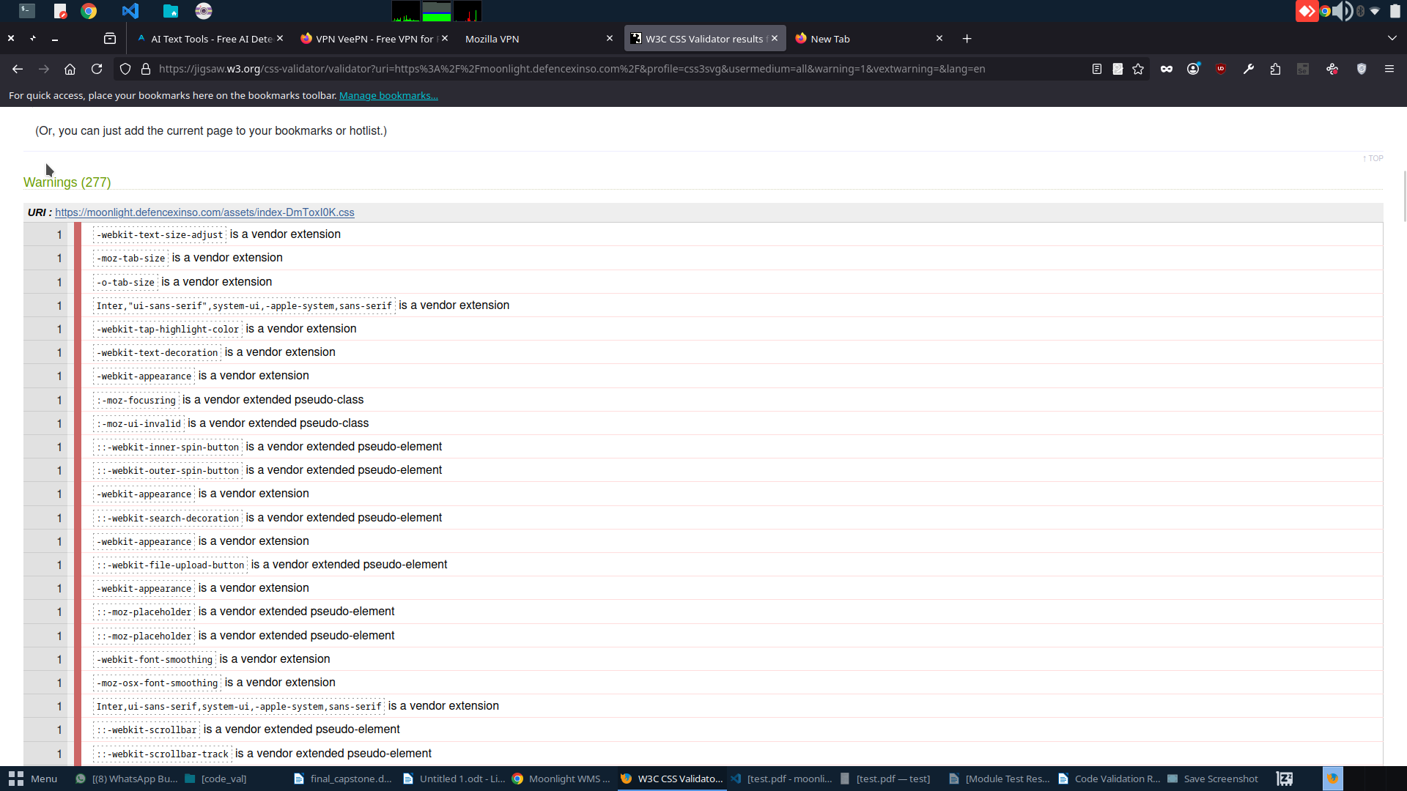Figure 13: W3C CSS Validator warning list showing vendor extension and CSS variable warnings.

3.6.2.5 CSS Validation Summary
Item | Result
Tool Used | W3C CSS Validation Service
CSS Standard | CSS Level 3 + SVG
Errors Found | 0
Warnings Found | 277
Main Warning Cause | Vendor-prefixed CSS, browser-specific pseudo-elements, CSS variables, and generated framework styles
Final Status | Passed with warnings

The CSS validation confirmed that Moonlight WMS successfully passed the W3C CSS validation check with no errors found. Although 277 warnings were reported, these warnings were mainly caused by vendor-specific browser support rules and generated CSS from the frontend build process. Overall, the CSS validation result confirms that the Moonlight WMS stylesheet is valid, browser-compatible, and acceptable for final project submission.

